

CAPSTONE PROJECT REPORT
Report 4 – Software Design Document

– Da Nang, Dec 2024 –
TABLE OF CONTENTS
I. Record of Changes 1
II. Software Design Document 2
1. System Design 2
1.1 System Architecture 2
1.1.1 System Architecture Diagram 2
Figure 1. System Architecture Diagram 2
1.1.2 System Architecture Explanation 2
1.2 Package Diagram 3
1.2.1 Package Descriptions 3
Table 1. Package Descriptions 3
1.2.2 Package Diagram 4
2. Database Design 5
Figure 5. Pickleball47 platform database diagram(SQLserver) 5
Table 2. Schema Descriptions(SQLserver) 6
3. Detailed Design 6
3.1 Login 6
3.2 Forgot Password 7
3.3 View Profile 8
8
3.4 Update Profile 8
3.5 Change Password 9
9
3.6 Search Field 9
3.7 Register 11
11
3.8 CRUD FIELD 11
12
3.9 Booking Field 14
3.10 Cancel Booking 15
3.12 Appove Booking Field 16
3.13 View Product Sport 17
3.14 OrderProduct 18
3.15 CancelOrder 19
3.16 View Revune Admin 20
3.17 CRUD User 21
3.18 Ban User 24
3.19 CRUD Product 25
3.20 ApproveOrder 27
3.21 CRUD Booking For Admin 28
3.22 CRUD Order Admin 30

I. Record of Changes
Date | A*, M, D | In charge | Change Description
*A - Added M - Modified D- Deleted

II. Software Design Document

1. System Design

1.1 System Architecture

1.1.1 System Architecture Diagram
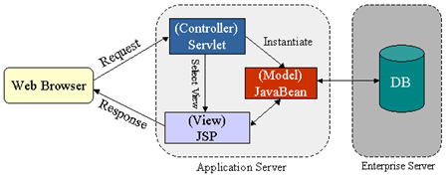

Figure 1. System Architecture Diagram

1.1.2 System Architecture Explanation
a. Presentation Layer (Client-Side/UI)
This layer is responsible for interacting with users and displaying information dynamically.
Technologies used: JSP, HTML, CSS, JavaScript, Bootstrap, jQuery, AJAX.
Functionality:
Displays courts availability and products for sale.
Allows users to book courts, purchase sports products, and manage their accounts.
Sends form inputs to the server using HTTP requests (GET, POST).
How it Works:
A user accesses the system through a web browser.
JSP pages dynamically generate HTML content.
JavaScript enhances UI interaction (e.g., AJAX for real-time updates).
User actions (e.g., login, booking) trigger HTTP requests to the servlet.
b. Business Logic Layer (Web Server – Servlet & Service Layer)
This layer processes requests, applies business logic, and interacts with the database.
Technologies used: Java Servlets, Service Classes, Java Beans, JDBC.
Functionality:
Handles user authentication and session management.
Processes court bookings and sports product orders.
Implements business rules (e.g., max bookings per user, stock availability).
Sends appropriate responses to the client (JSP pages or JSON for AJAX).
Key Components:
Servlets (Controller Layer)
Act as request handlers, processing HTTP requests and generating responses.
Example: LoginServlet, BookingServlet, OrderServlet.
Service Layer (Business Logic)
Implements application logic, like verifying booking conflicts or calculating discounts.
DAO (Data Access Object) Layer
Manages interactions with the database using JDBC or JPA (Hibernate).
Example: UserDAO, BookingDAO, ProductDAO.
How it Works:
The user submits a request (e.g., booking a court).
The servlet processes the request and calls the appropriate Service Layer.
The Service Layer applies business rules and interacts with the DAO Layer to retrieve/update the database.
The servlet sends a response back to the JSP page for display.
c. Data Layer (Database Server)
Stores system data, including users, bookings, products, payments, and transactions.
Technologies used: MySQL, PostgreSQL, Oracle DB.
Functionality:
Stores and retrieves data efficiently.
Ensures data consistency and integrity.
Uses indexes and queries for performance optimization.
How it Works:
The DAO Layer sends SQL queries via JDBC to fetch/update data.
The database processes the queries and returns the results.
The DAO Layer converts results into Java objects and passes them to the Service Layer.

1.2 Package Diagram

1.2.1 Package Descriptions
No | Package | Description
01 | Pickleball47-fe | Pickleball47’s front end consists of a structured arrangement of files and folders that organize and manage the project's user interface components. This organization allows for efficient management and easy navigation within the project.
02 | Pickleball47-be | Pickleball47 project's back end is a structured system of files and folders that organize and manage the project's server-side components. This organization facilitates efficient management and easy navigation within the project, ensuring that developers can quickly find and modify the necessary files.

Table 1. Package Descriptions

1.2.2 Package Diagram
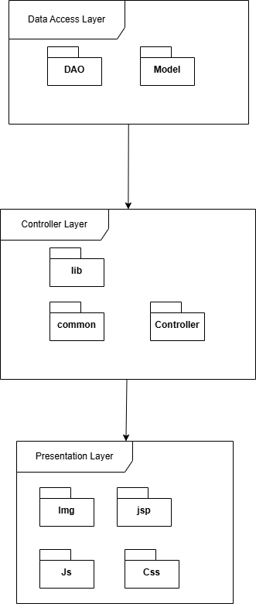

2. Database Design
2.1 MySQL
2.1.1 Database diagram
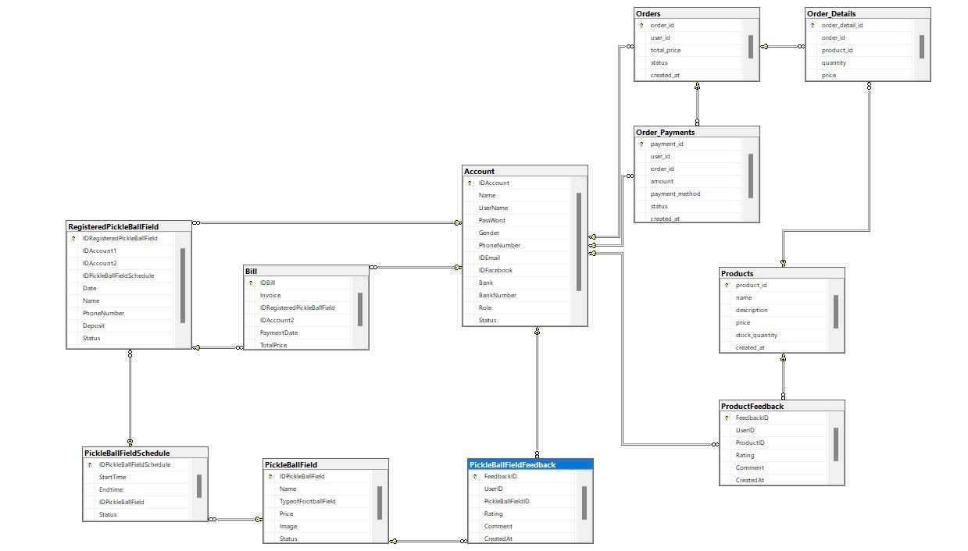

Figure 5. Pickleball47 platform database diagram(SQLserver)

2.1.2 Schema Descriptions
No | Schema | Description
01 | Account(User) | Stores user details such as login credentials, personal information, and payment details.
02 | RegisteredPickleBallField Table | Stores information about users who have registered to book pickleball fields.
03 | PickleBallFieldSchedule Table | Manages schedule details for pickleball fields.
04 | PickleBallField Table | Stores details of different pickleball fields.
05 | PickleBallFieldFeedback Table | Stores feedback and ratings for pickleball fields.
06 | Bill Table | Stores billing information for registered pickleball field users.
07 | Orders Table | Stores customer orders for sports products
08 | Order_Details Table | Stores product details associated with an order.
09 | Order_Payments Table | Stores payment details for orders.
10 | Products Table | Stores details of sports products available for sale.
11 | ProductFeedback Table | Stores user feedback and ratings for products.

Table 2. Schema Descriptions(SQLserver)

3. Detailed Design

3.1 Login
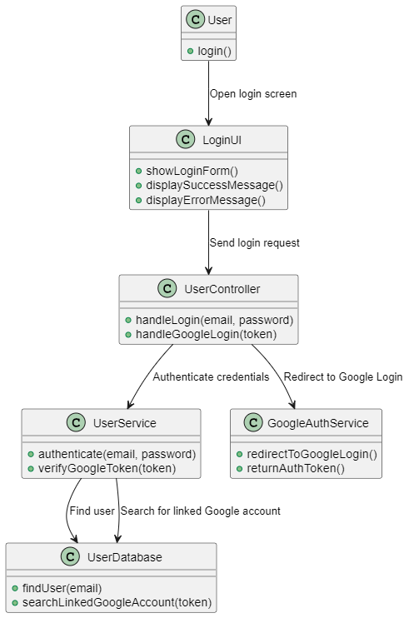
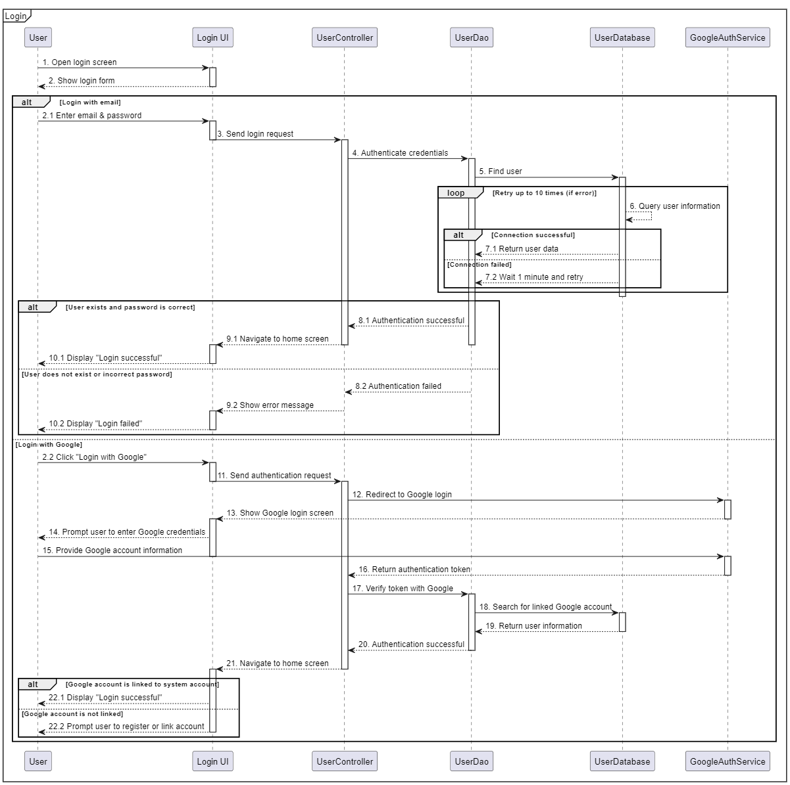

3.2 Forgot Password
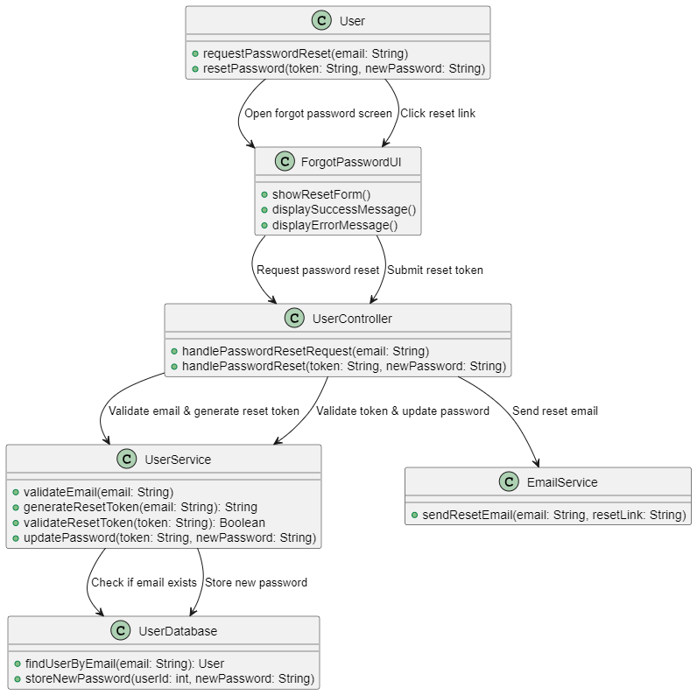
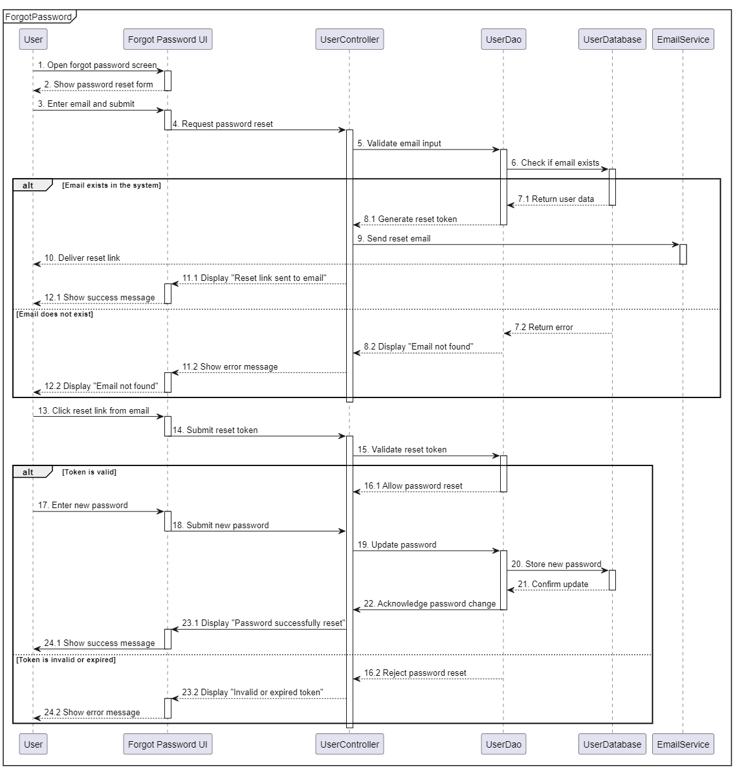

3.3 View Profile
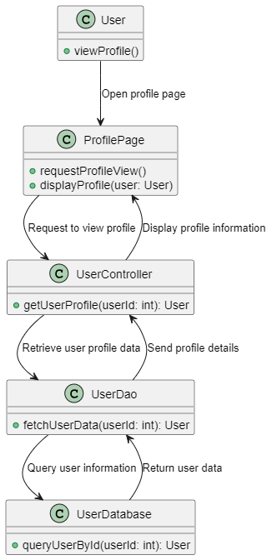

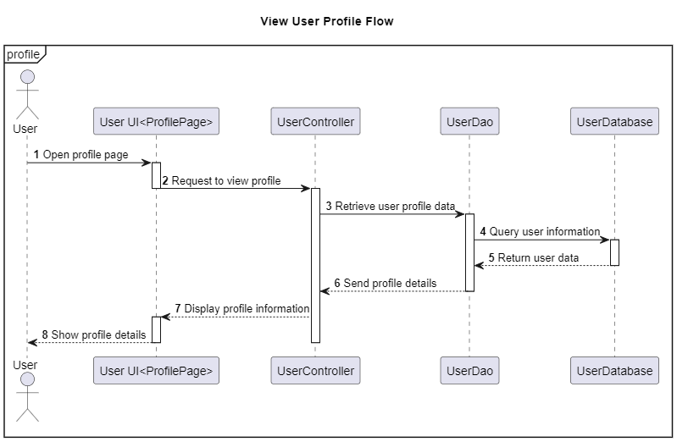

3.4 Update Profile
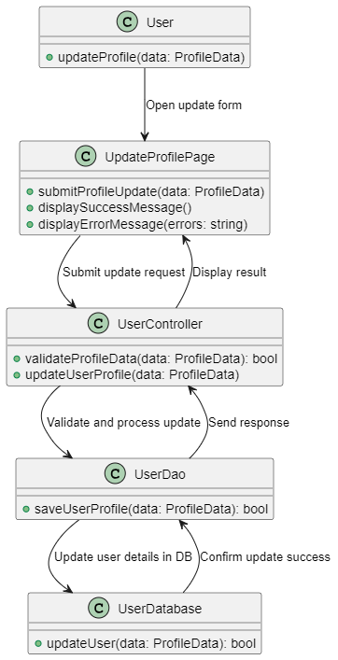
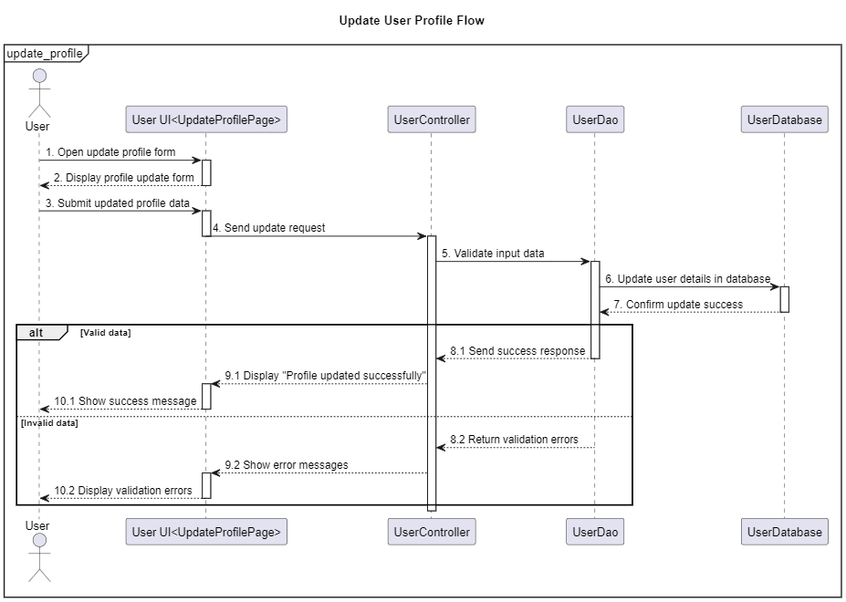

3.5 Change Password
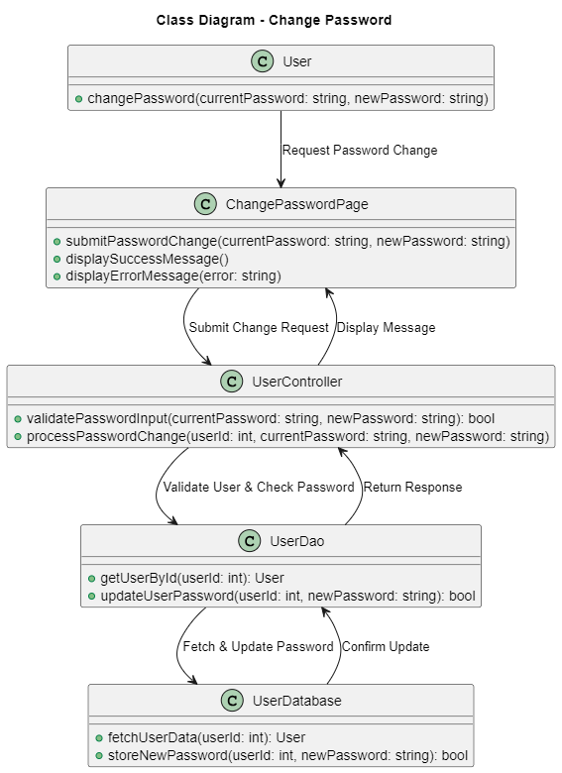
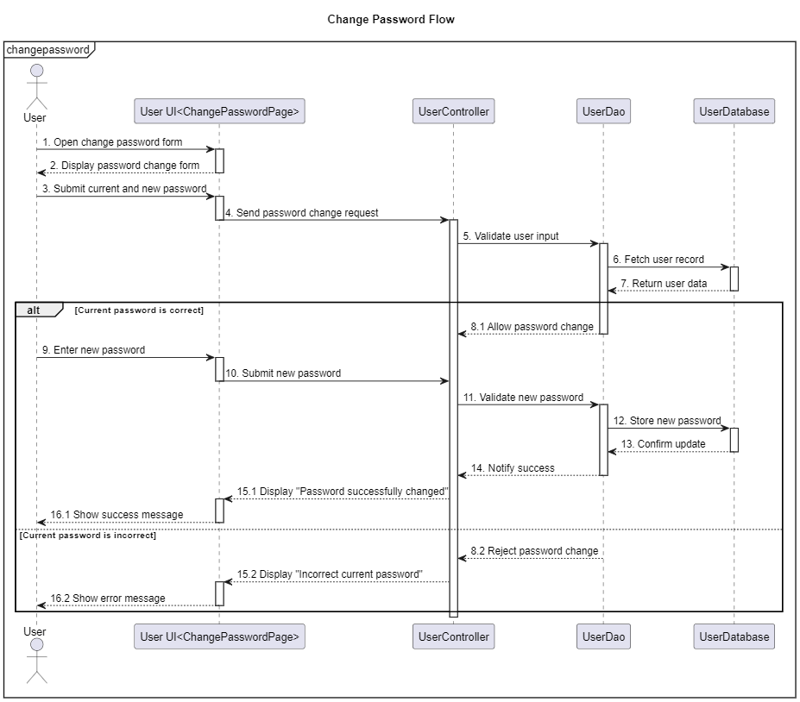

3.6 Search Field

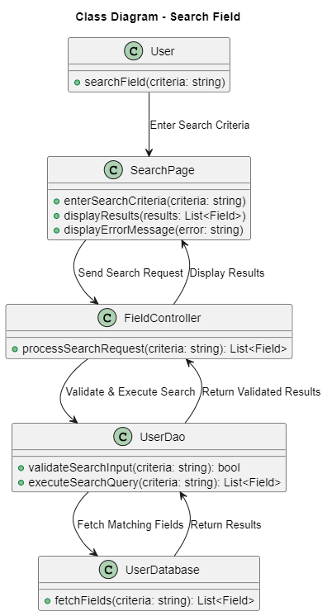
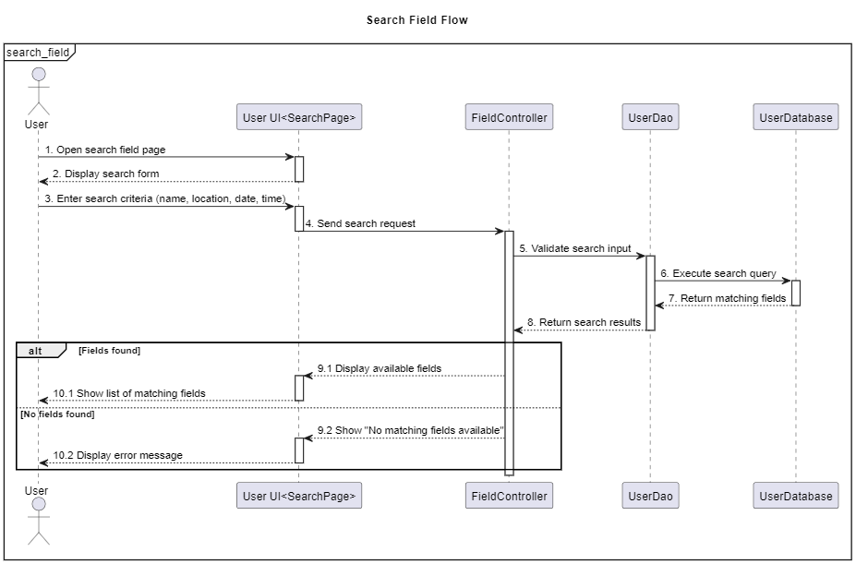

3.7 Register

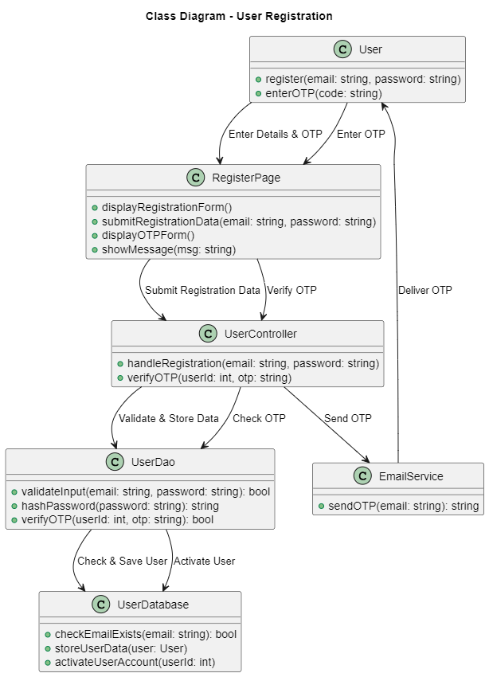
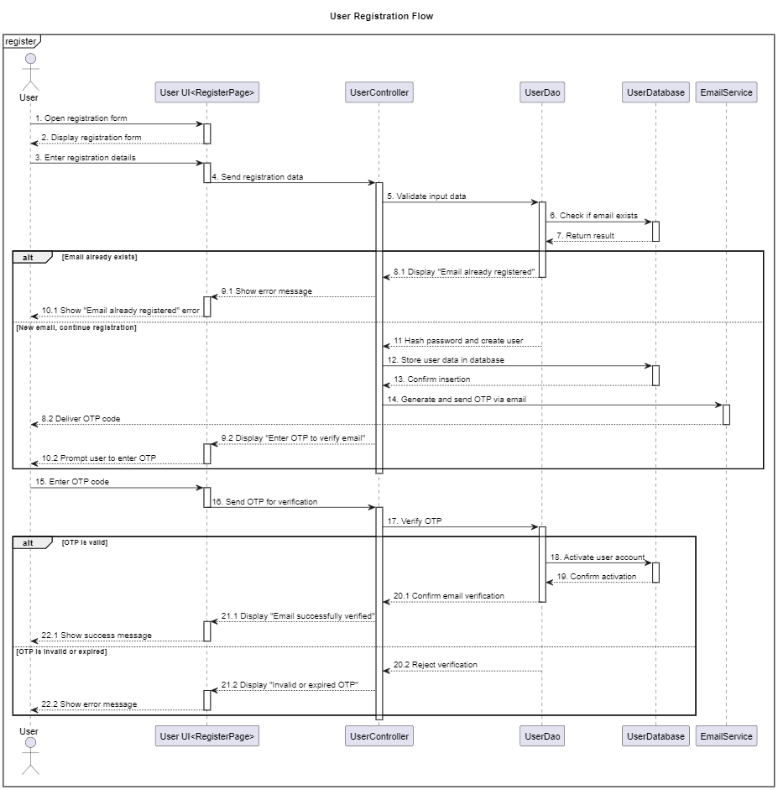

3.8 CRUD FIELD
Create Field
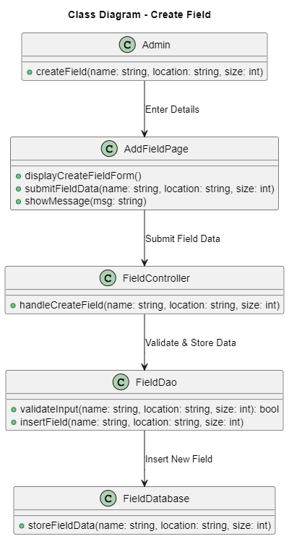
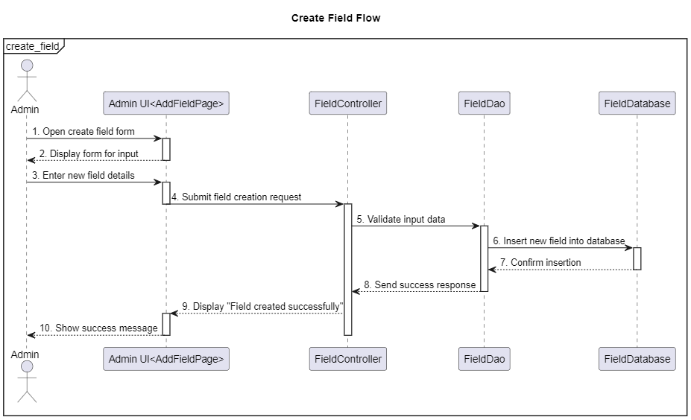
View Field
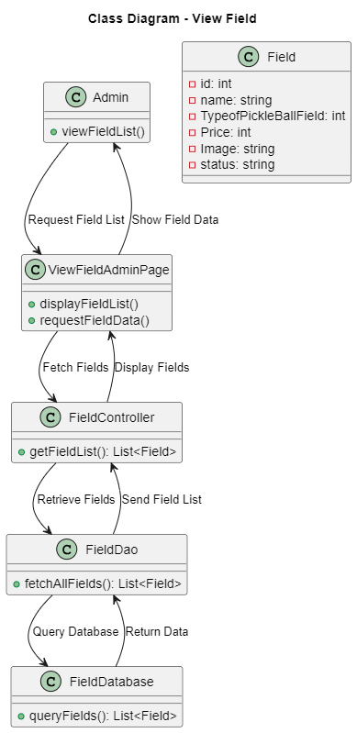
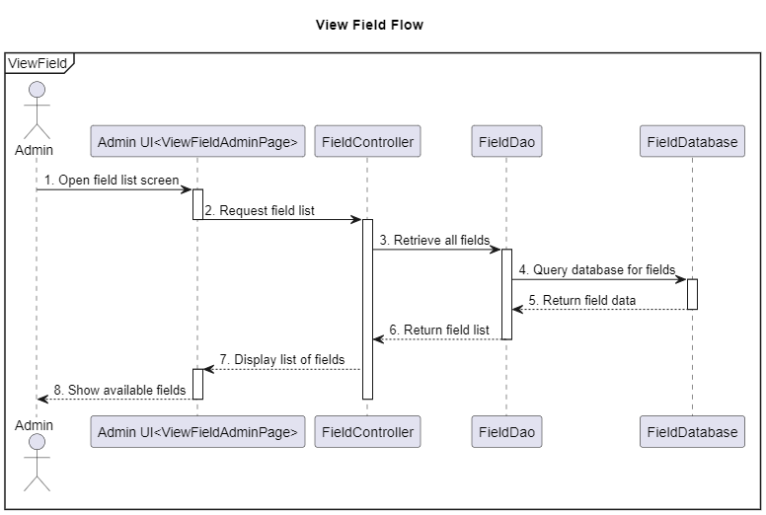
Update Field
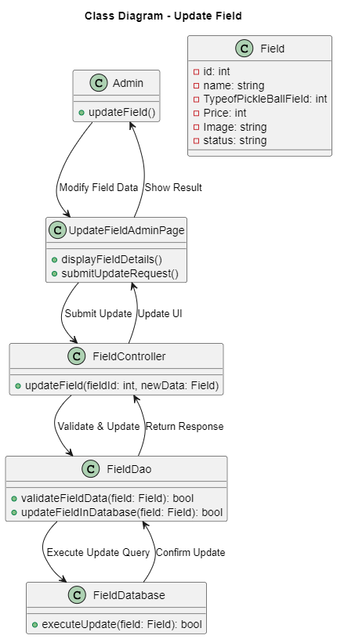
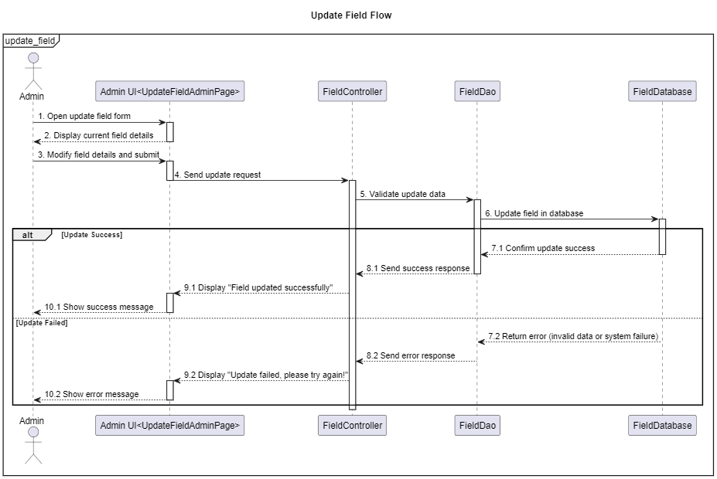
Delete Field
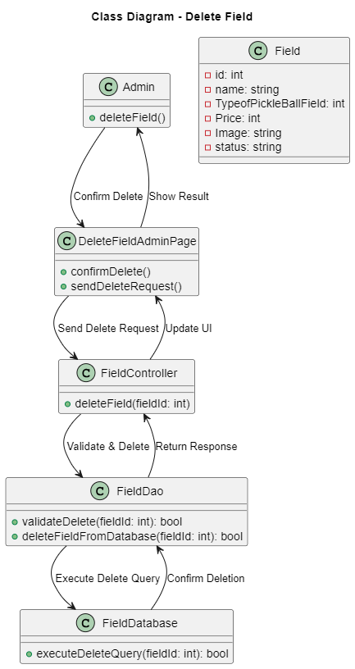
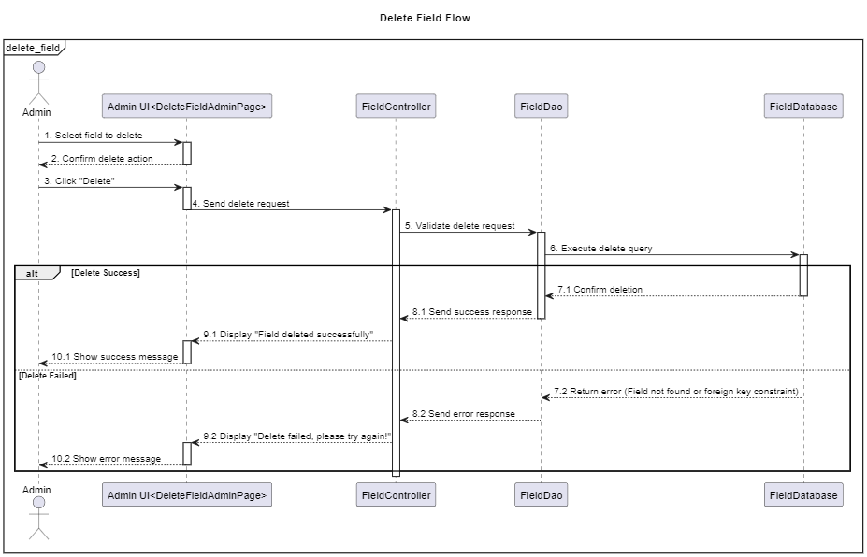

3.9 Booking Field

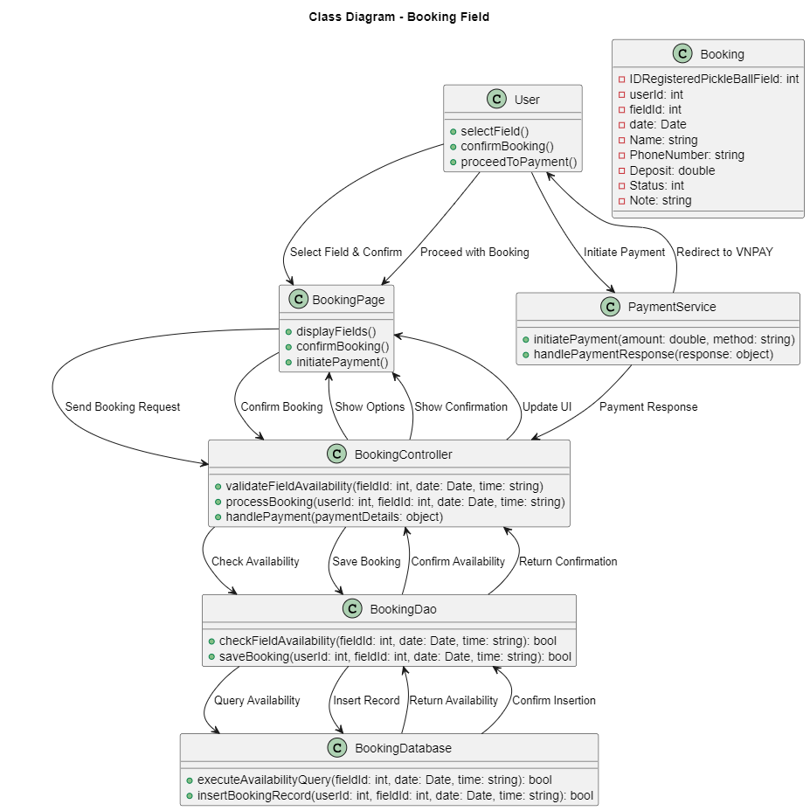
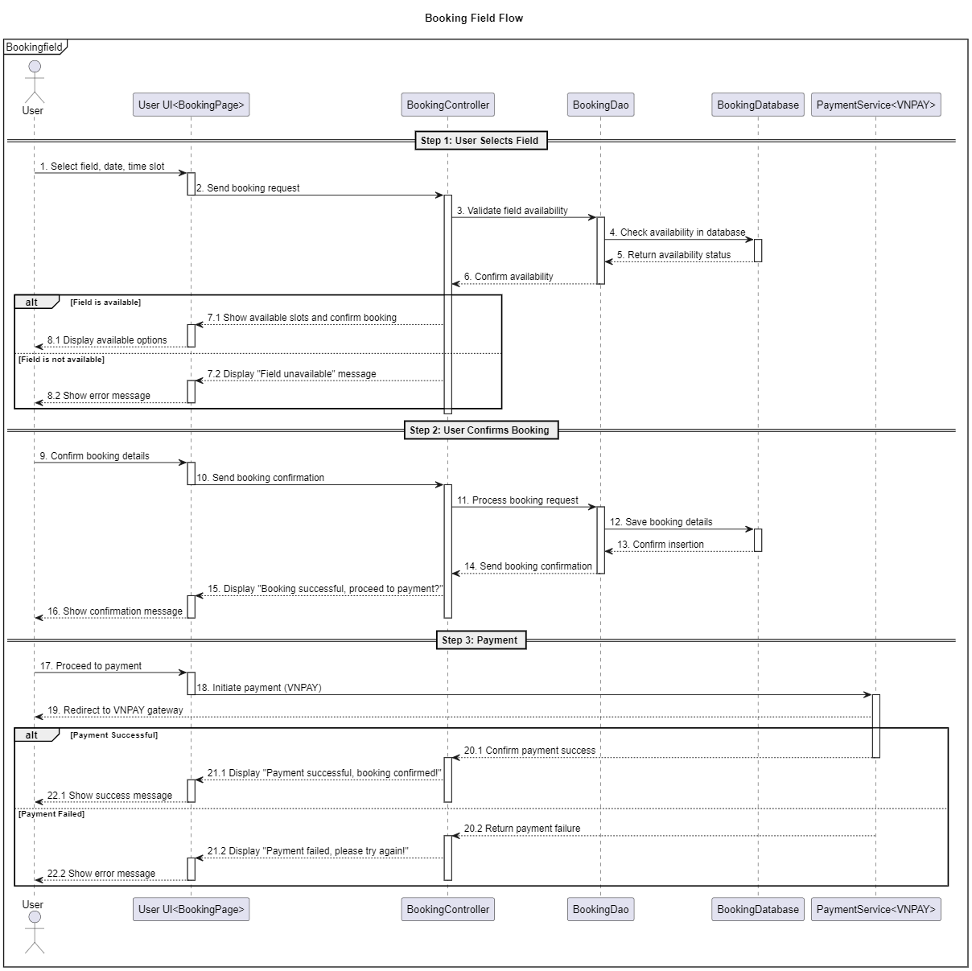

3.10 Cancel Booking
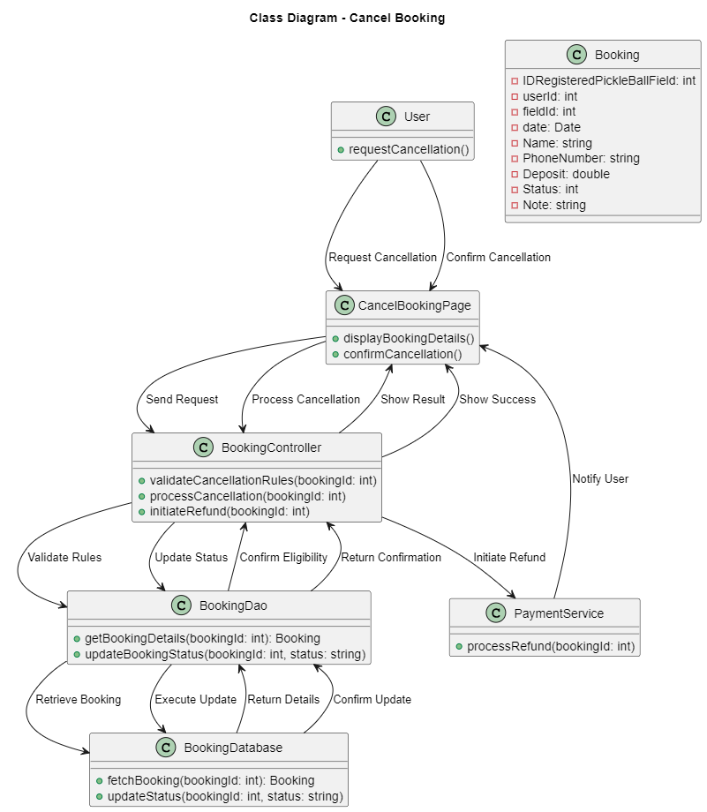
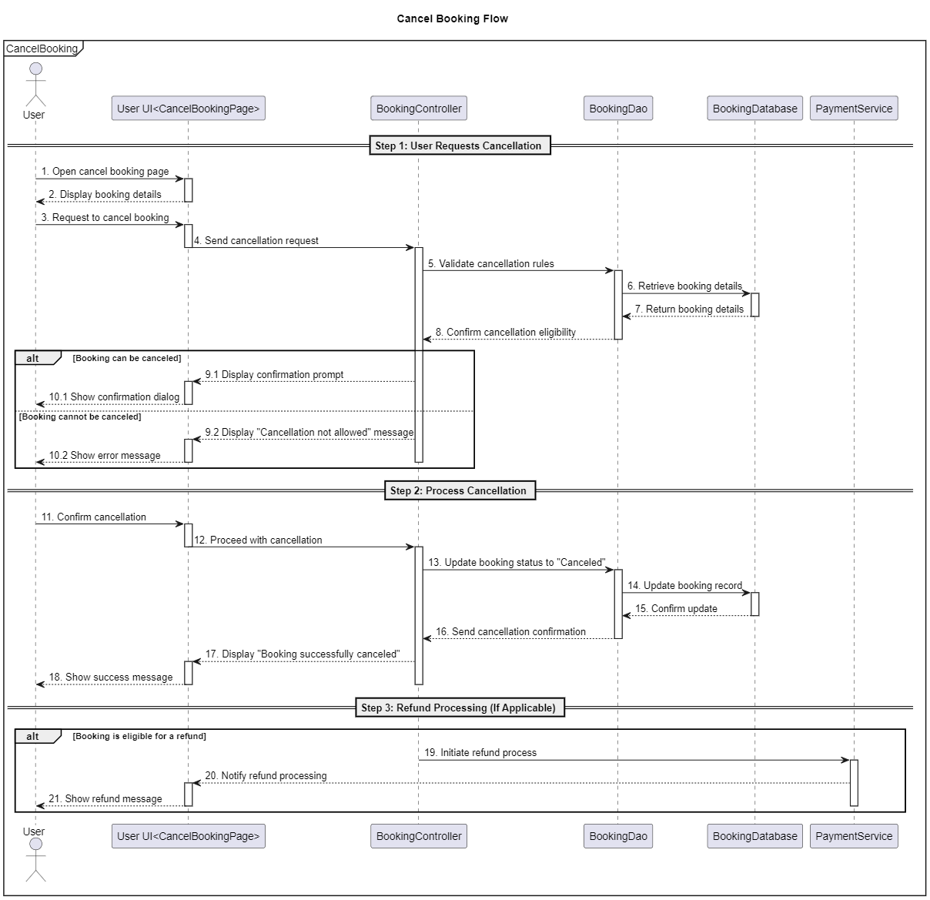

3.12 Appove Booking Field
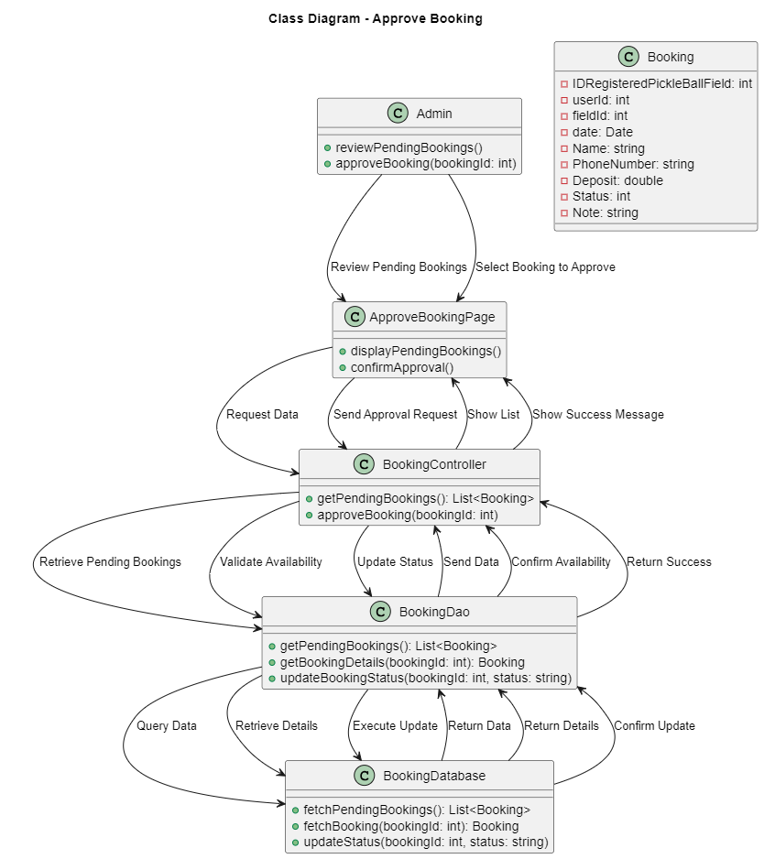
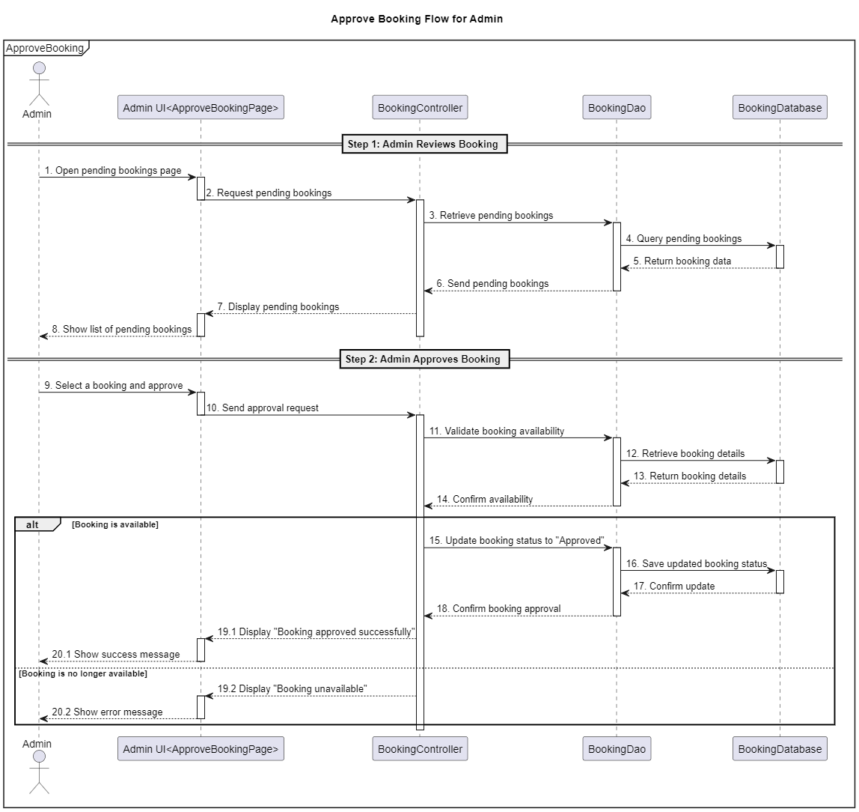

3.13 View Product Sport for User
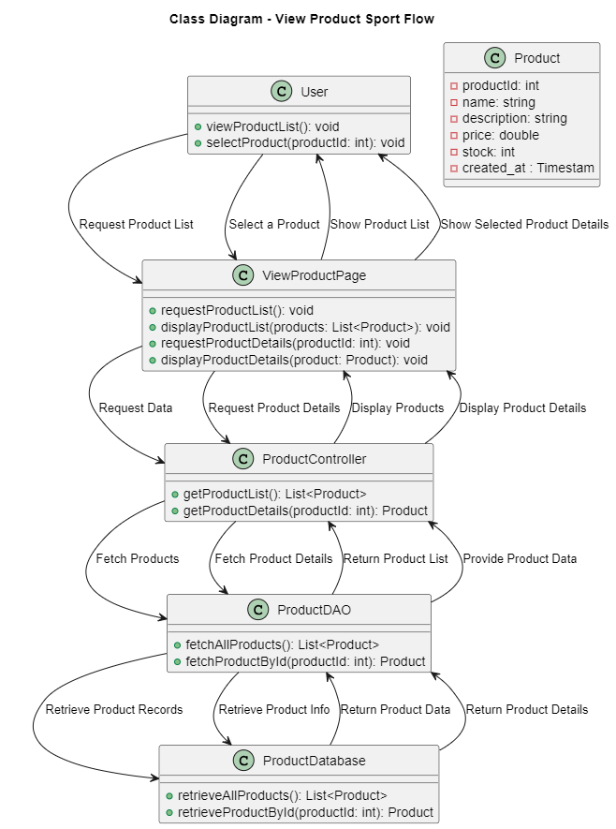
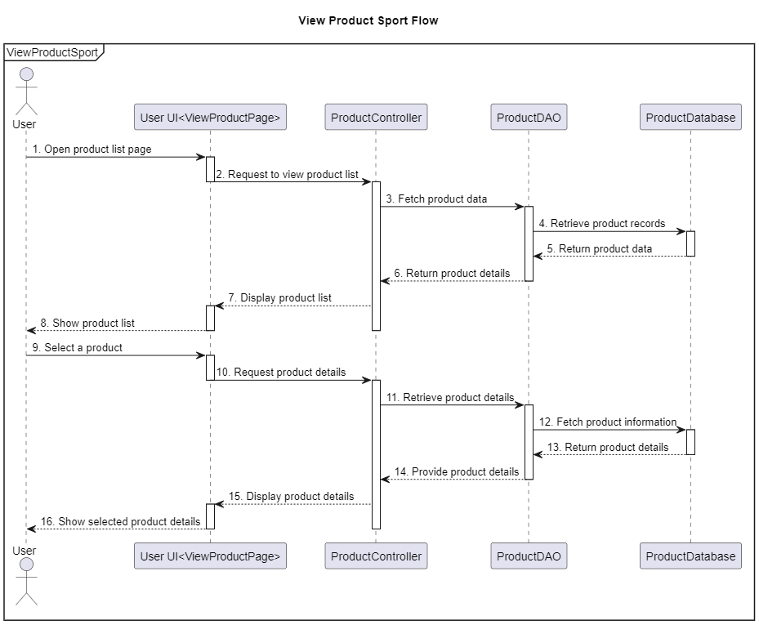

3.14 OrderProduct

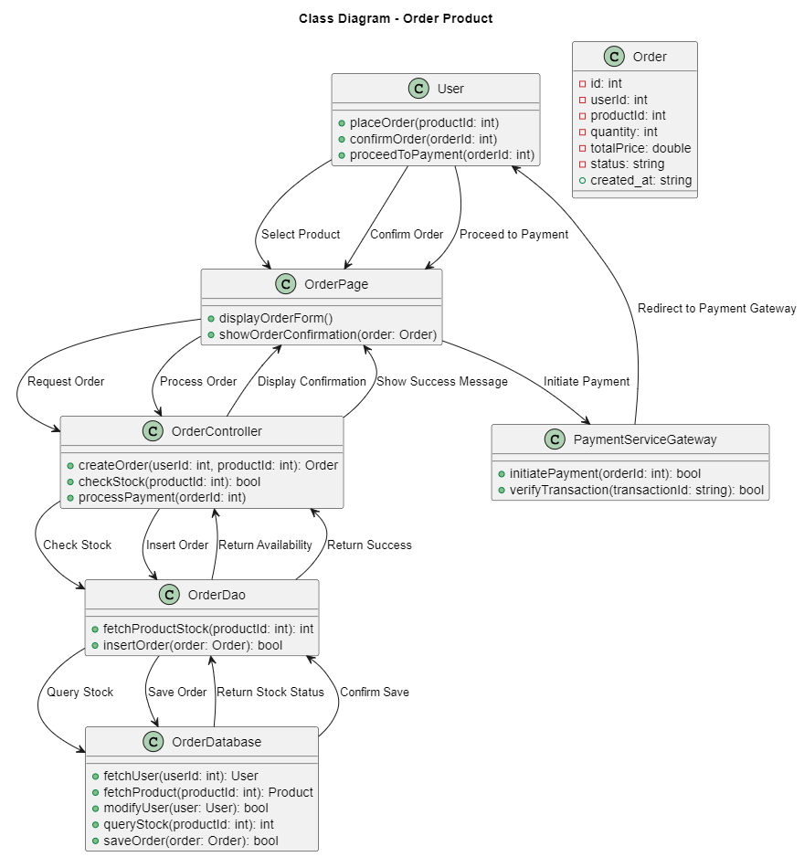
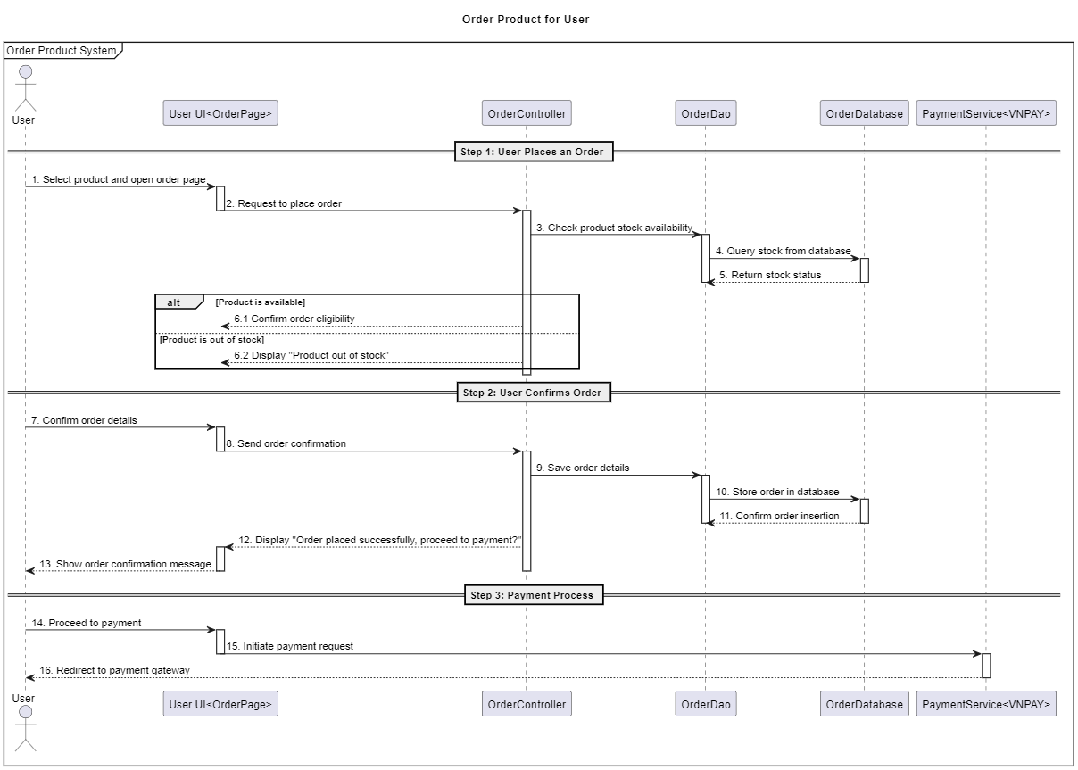

3.15 CancelOrder
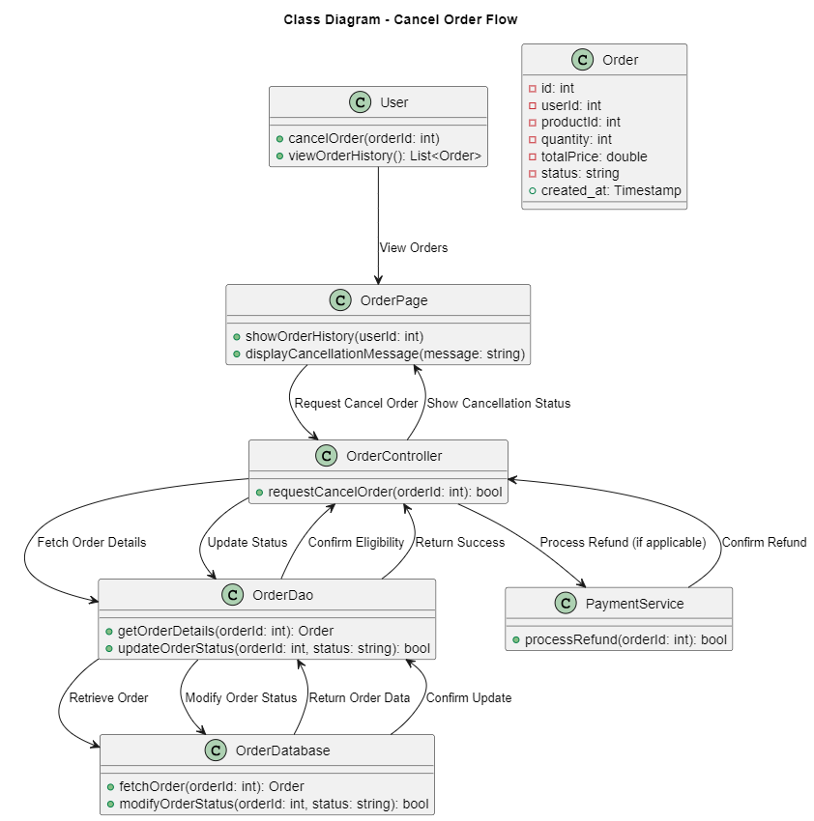
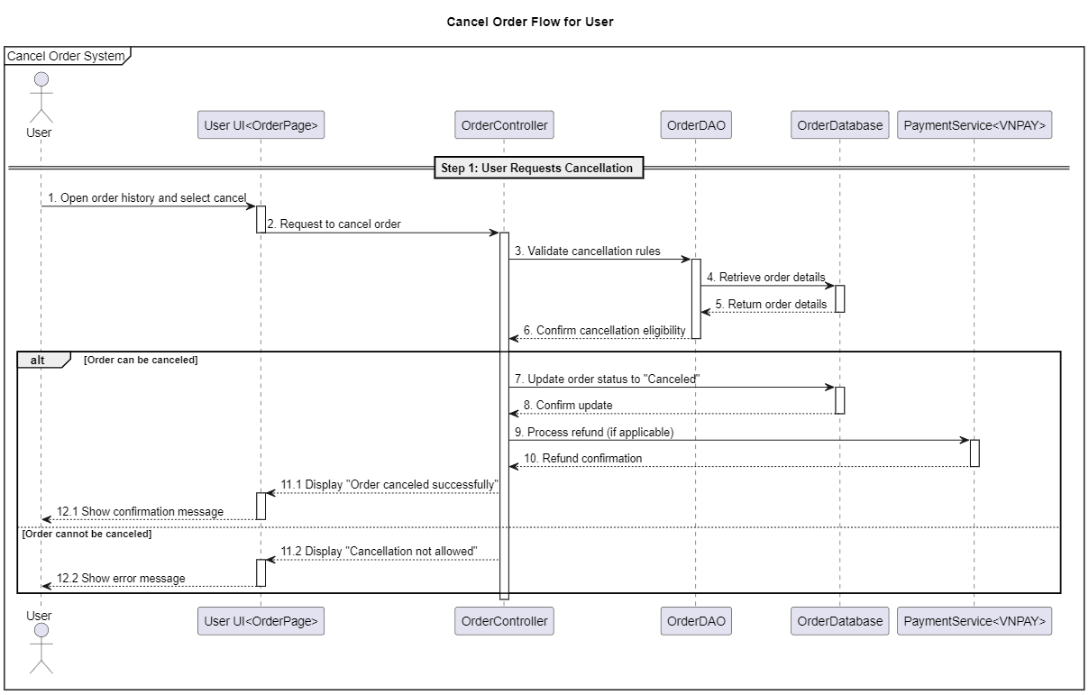

3.16 View Revune Admin
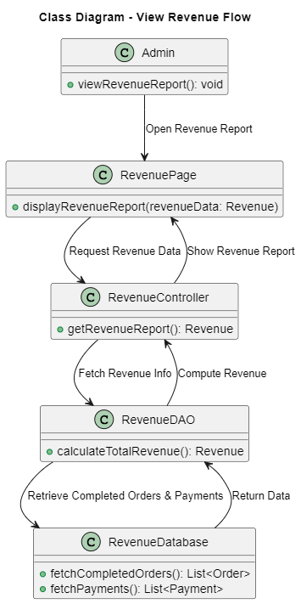
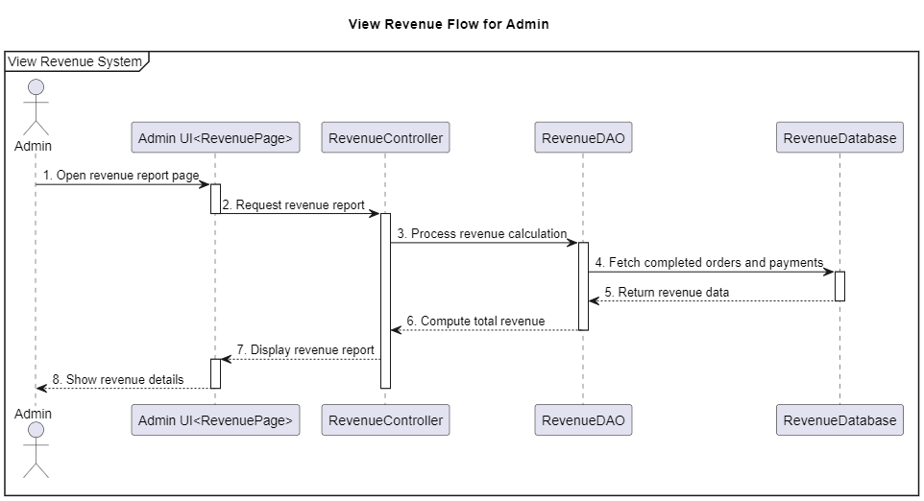

3.17 CRUD User
Create User
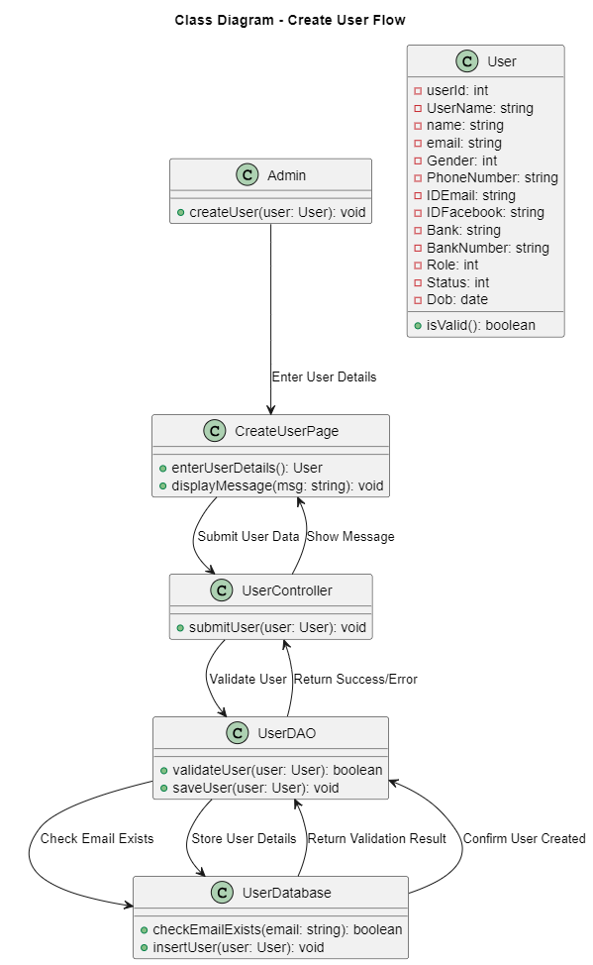
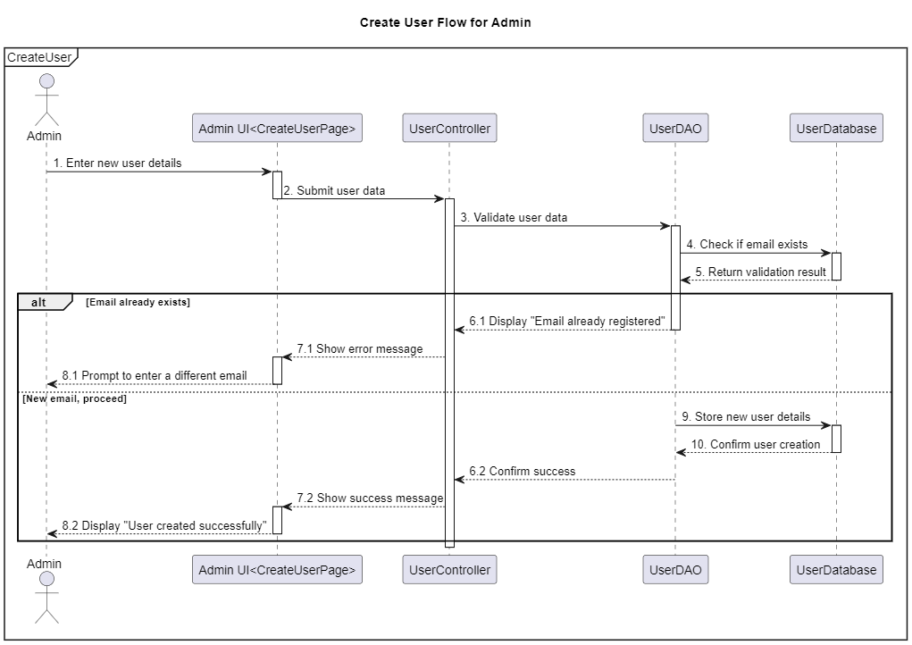
View User
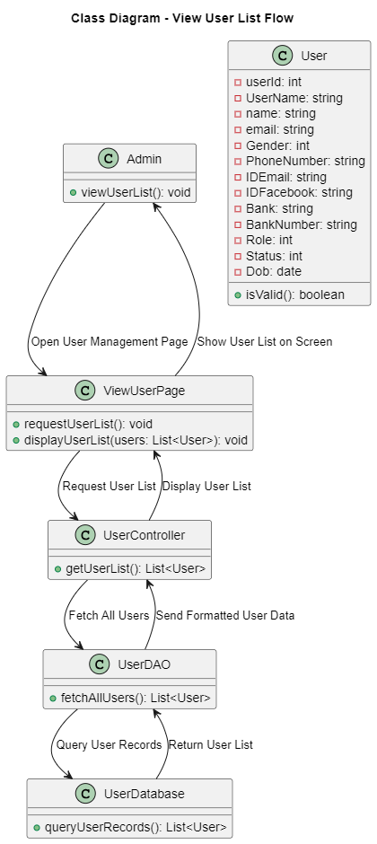
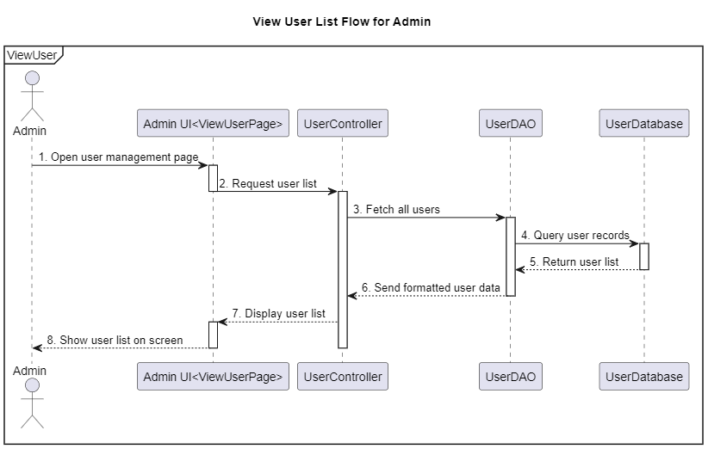
Update User
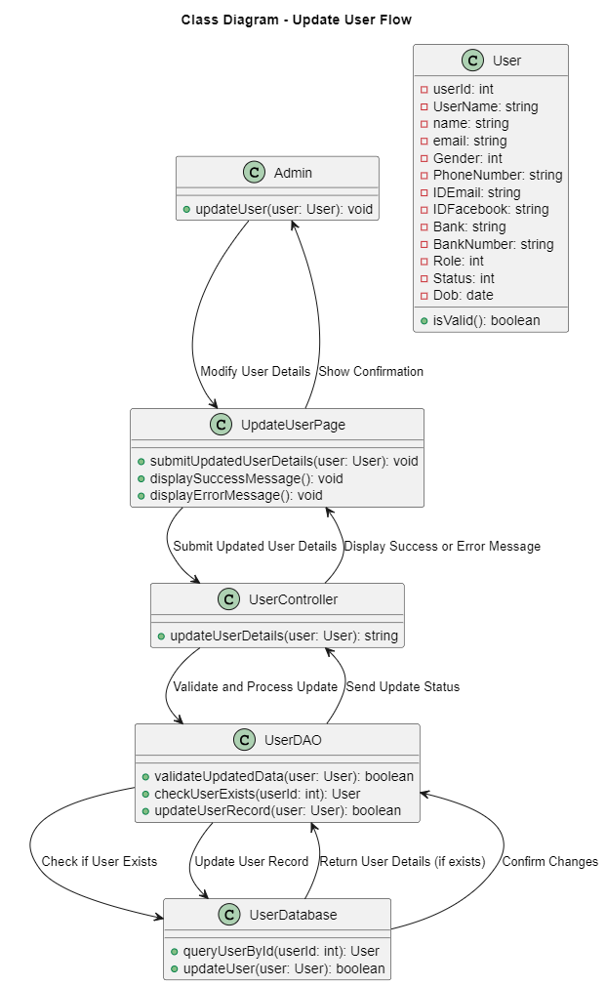
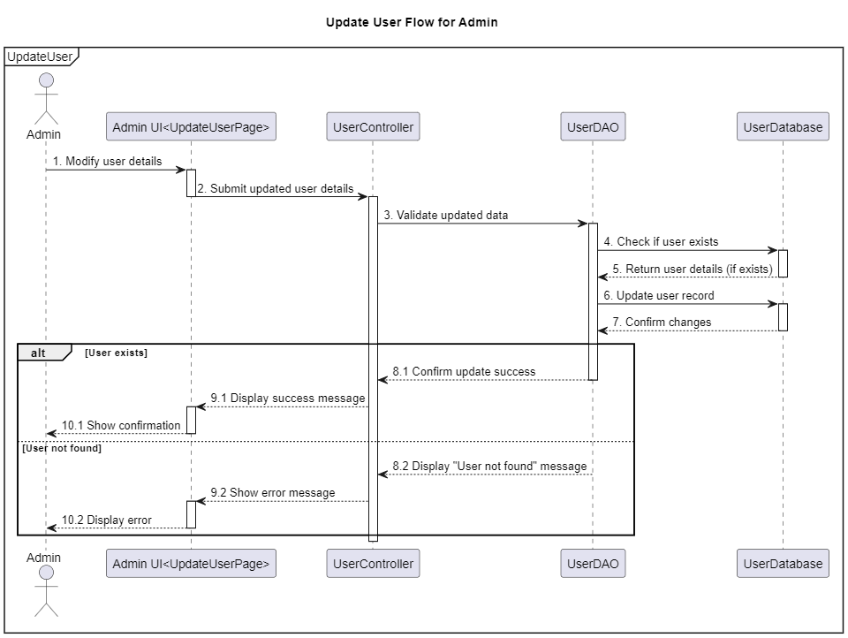
Delete User
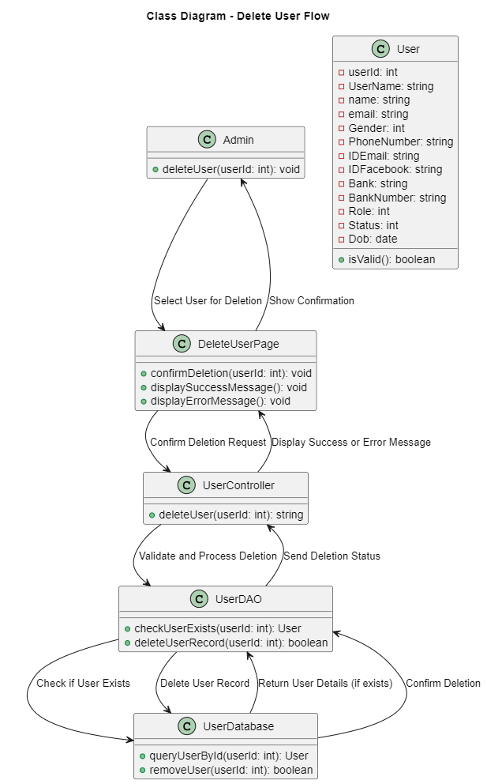
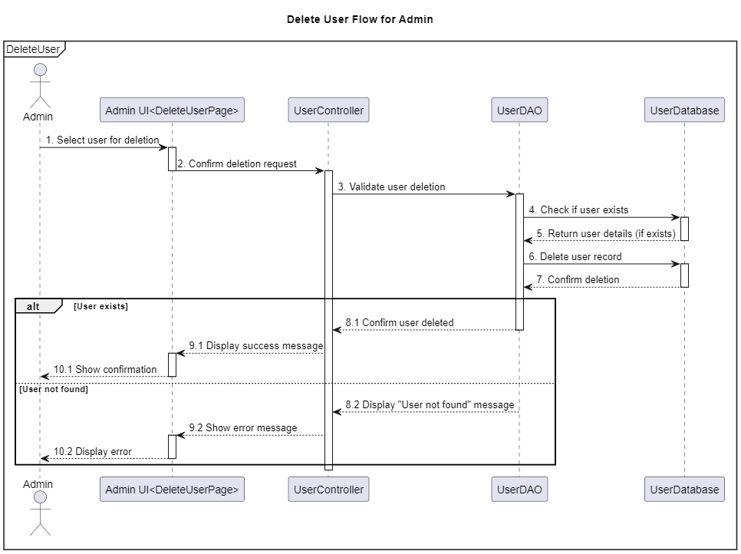

3.18 Ban User
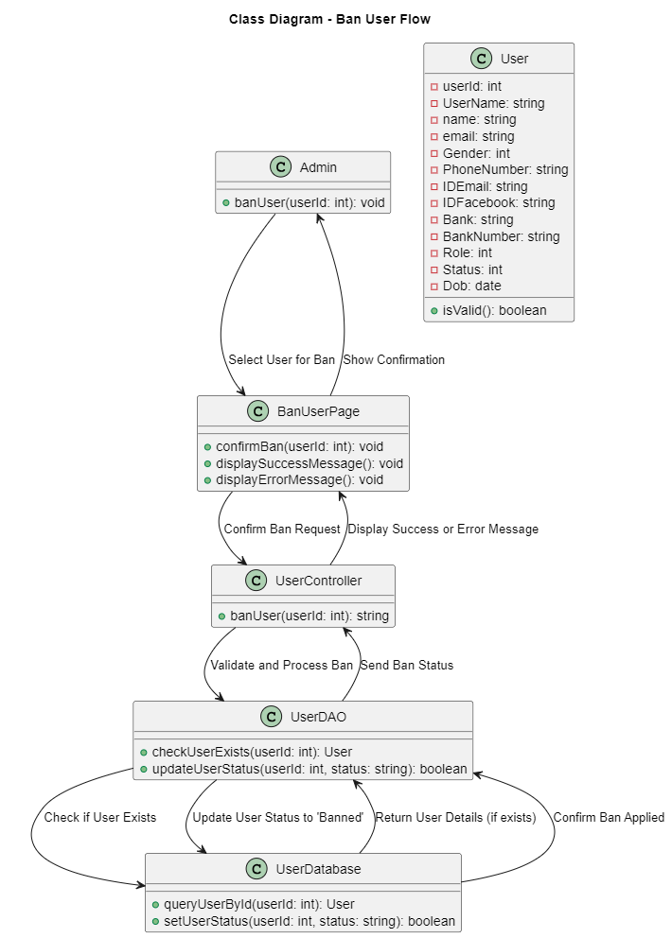
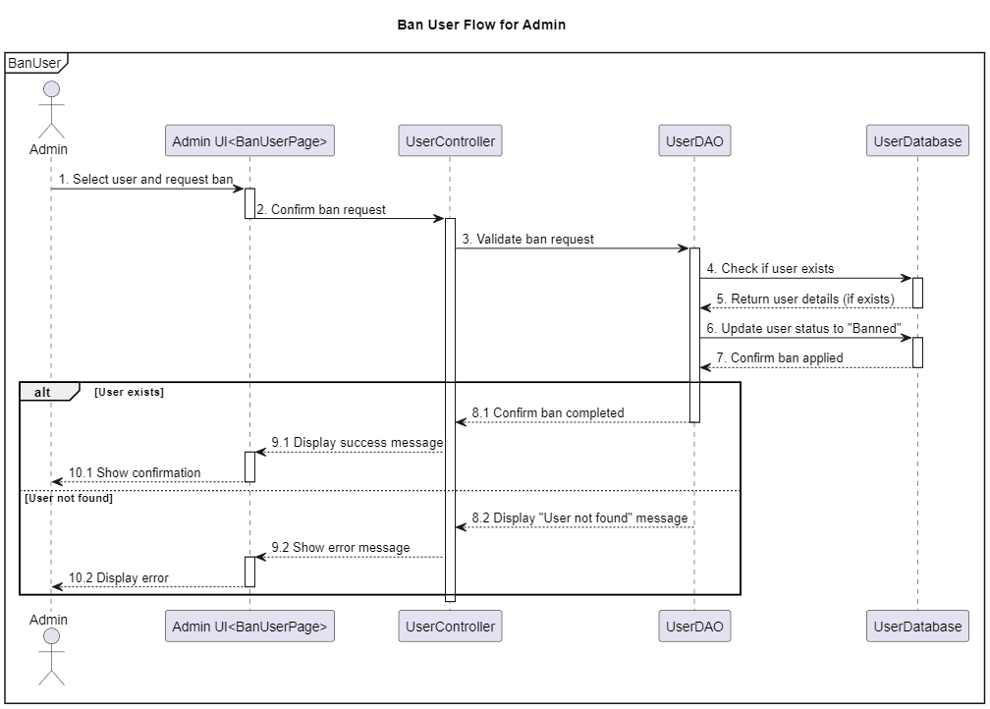

3.19 CRUD Product
Create Product
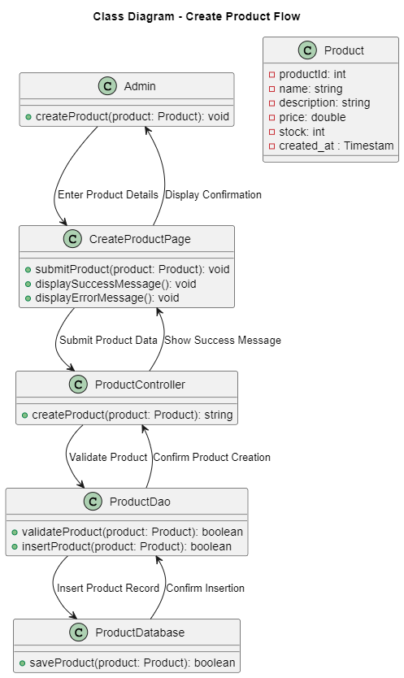
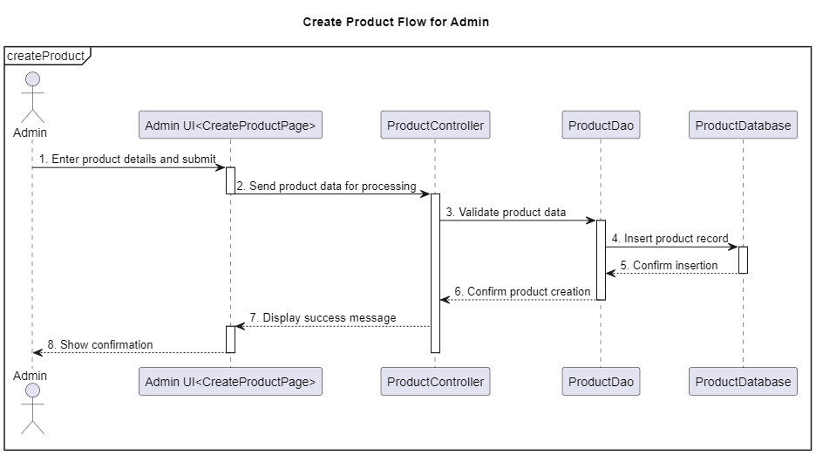
View Product
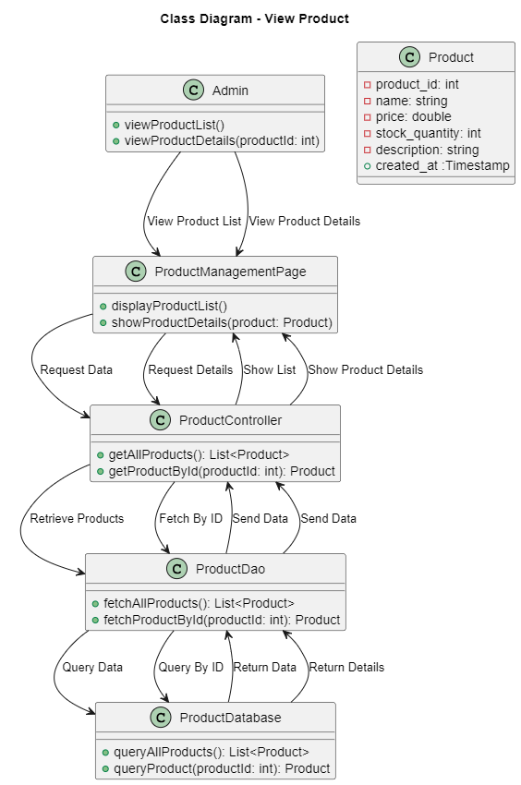
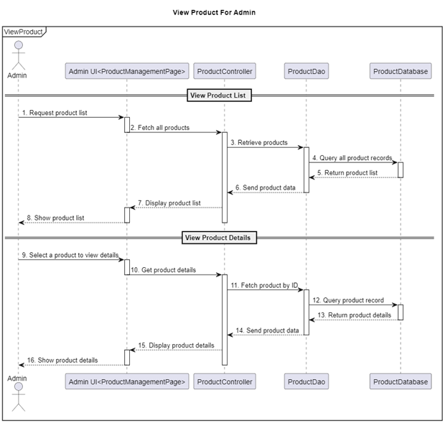
Update Product
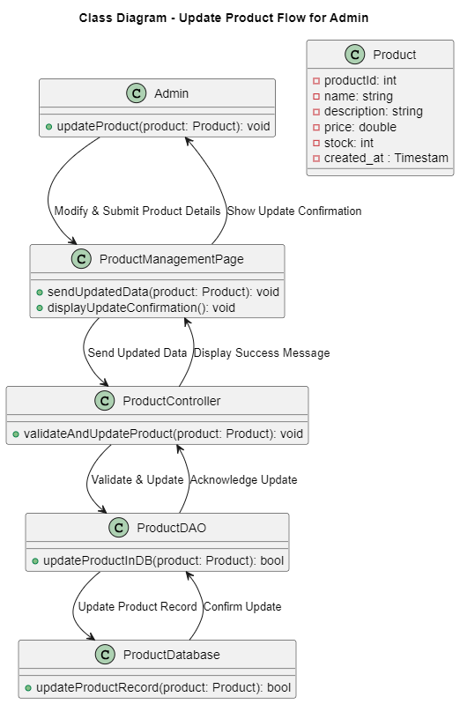
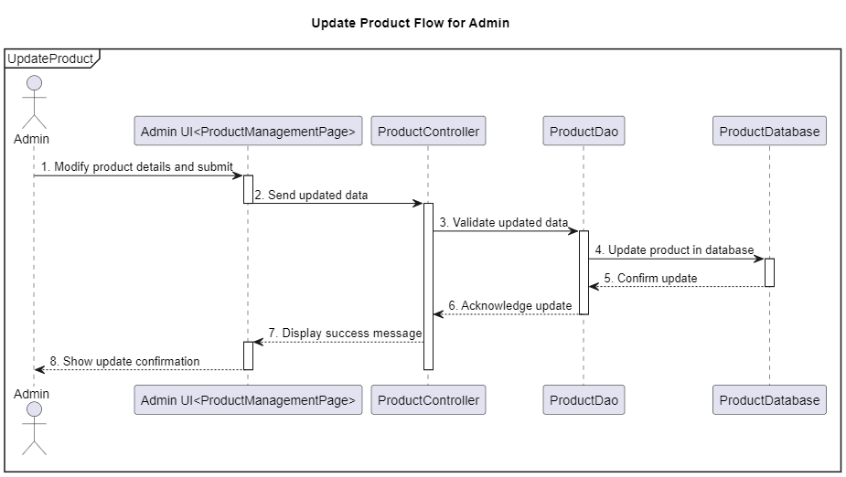
Delete Product
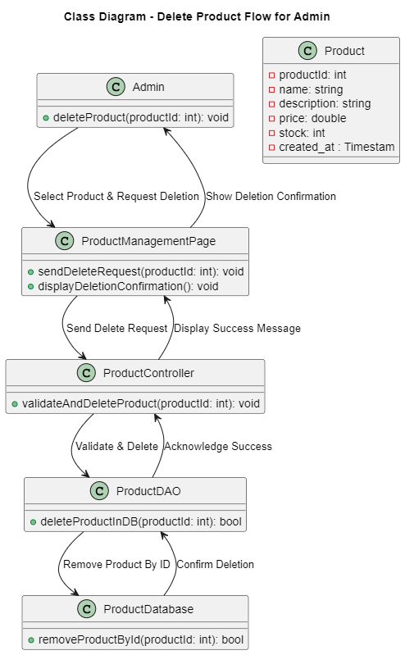
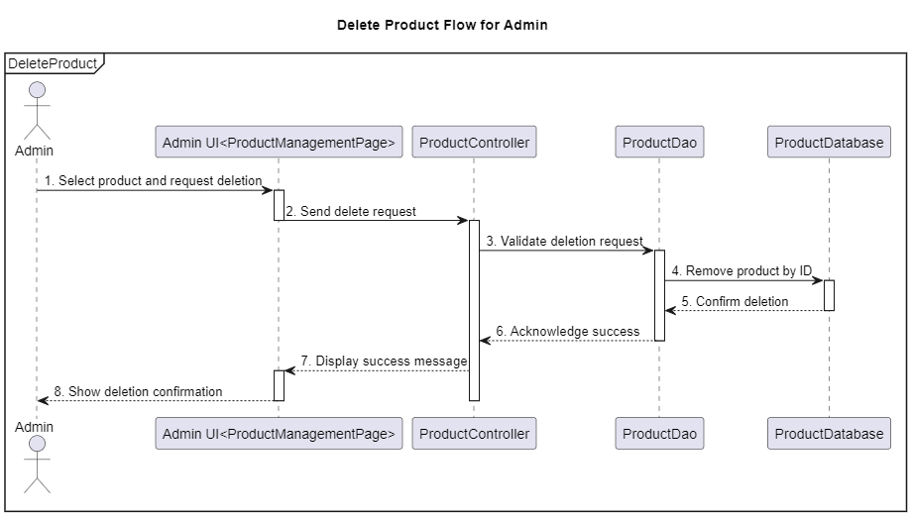

3.20 ApproveOrder
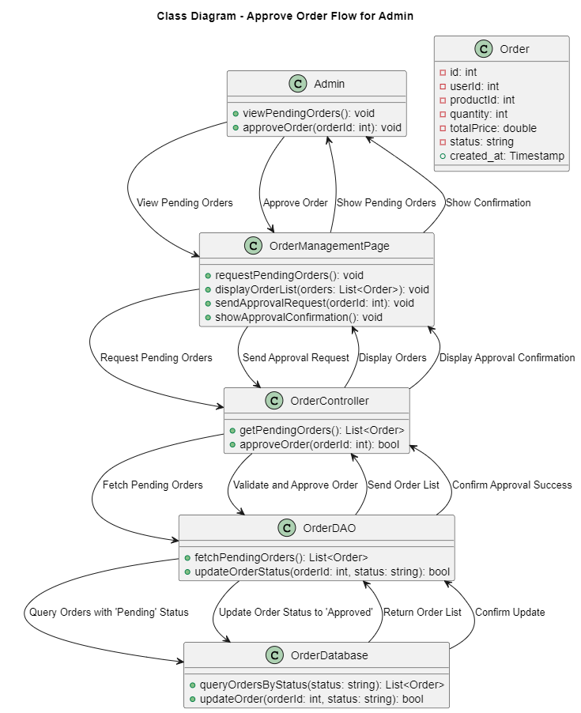
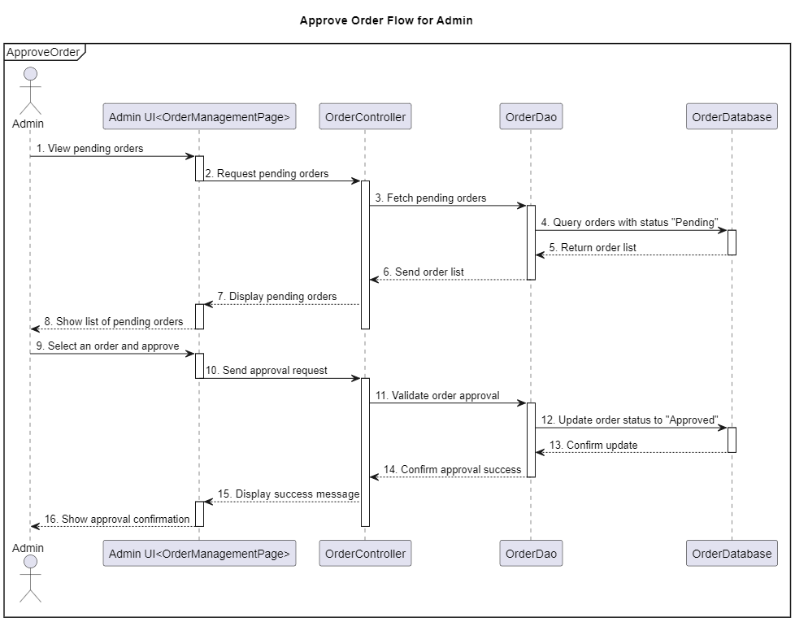

3.21 CRUD Booking For Admin
Create Booking
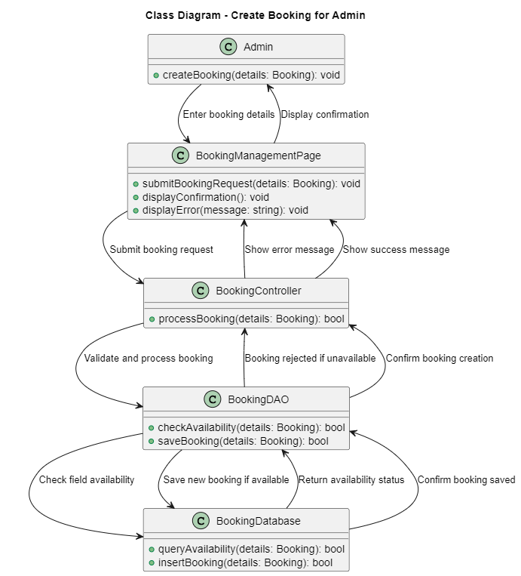
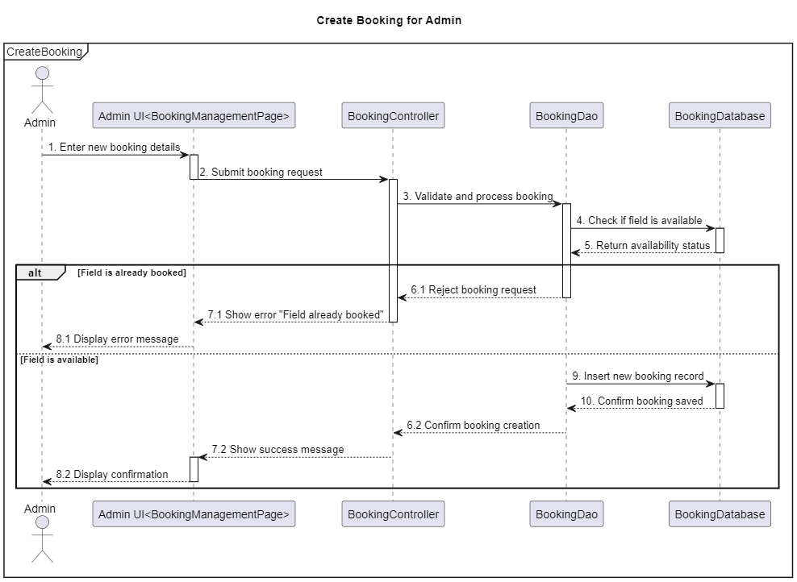
View Booking
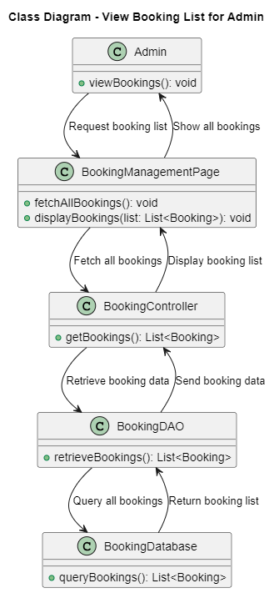
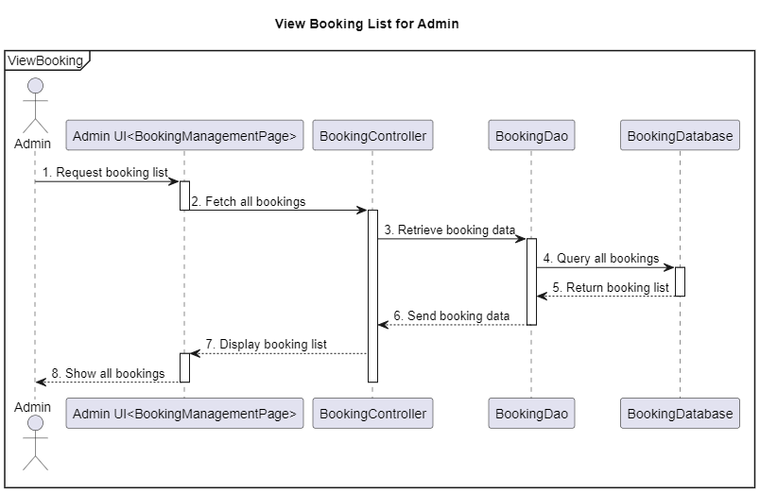
Update Booking
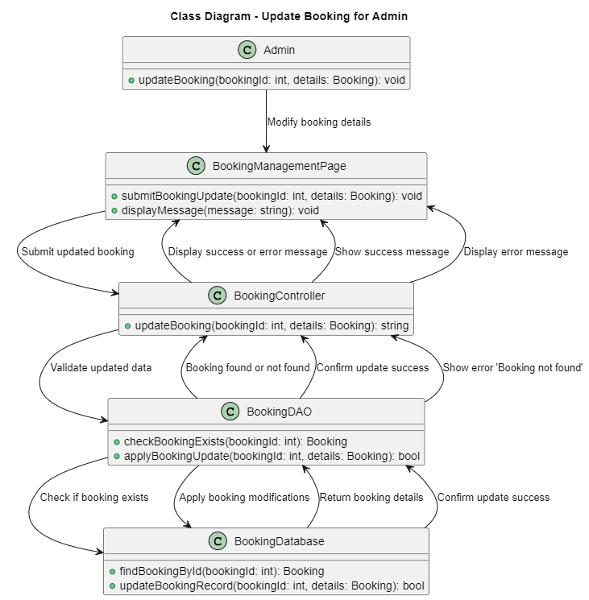
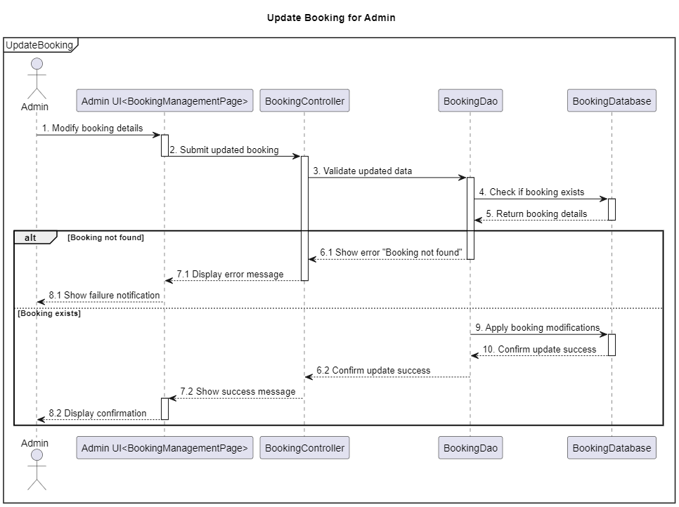
Delete Booking
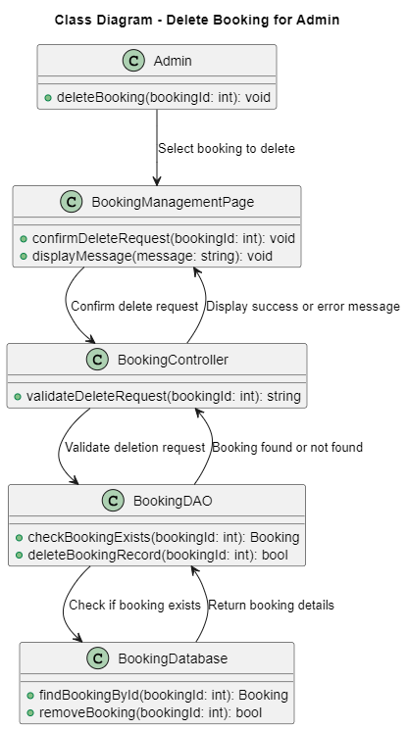
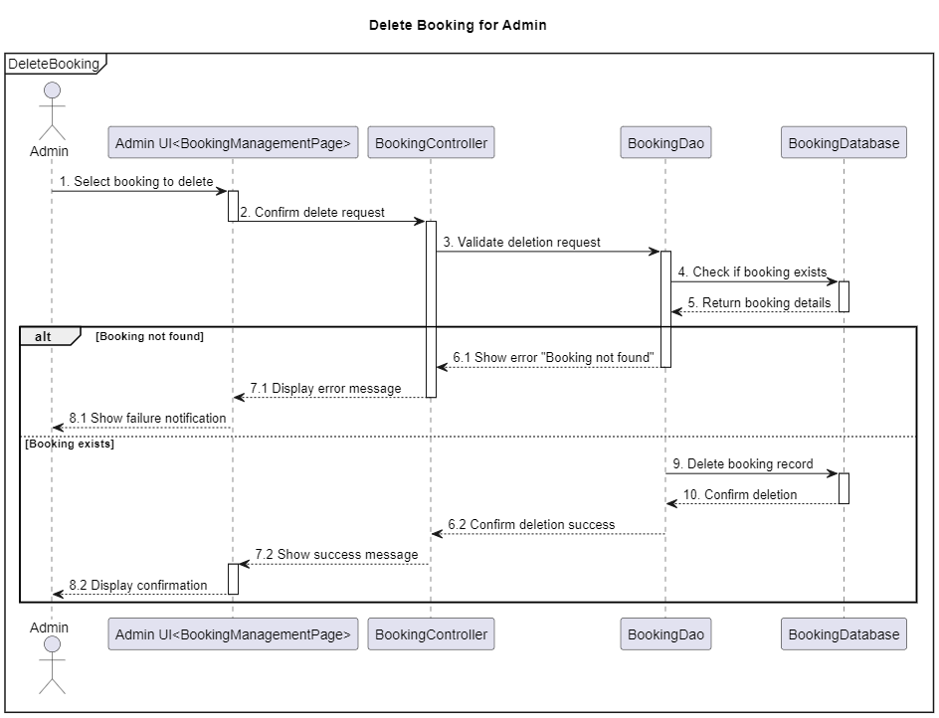

3.22 CRUD Order Admin
Create Order
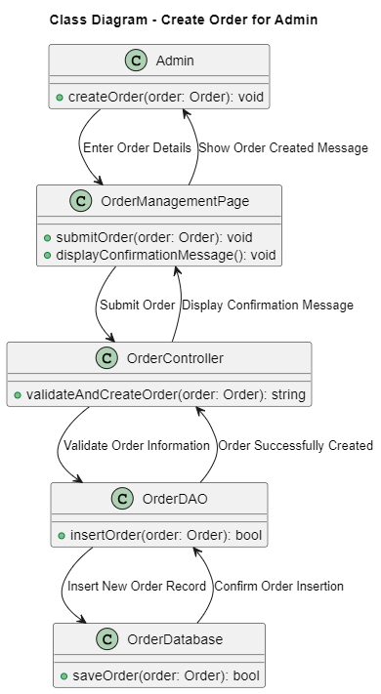
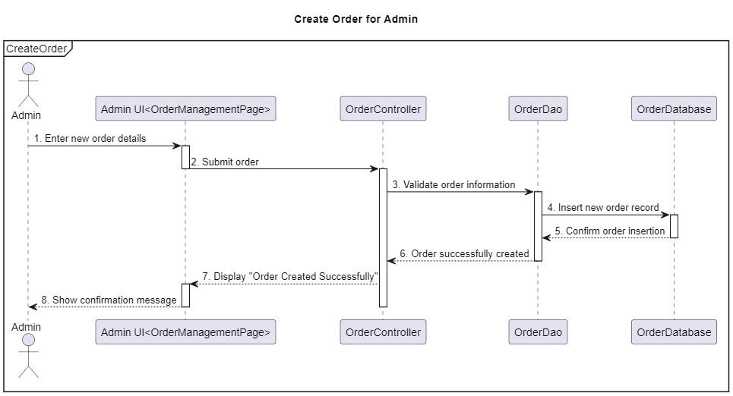
View Order
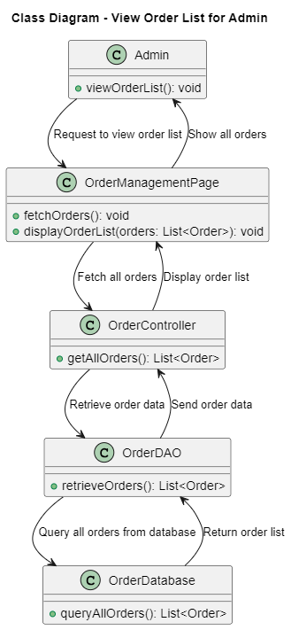
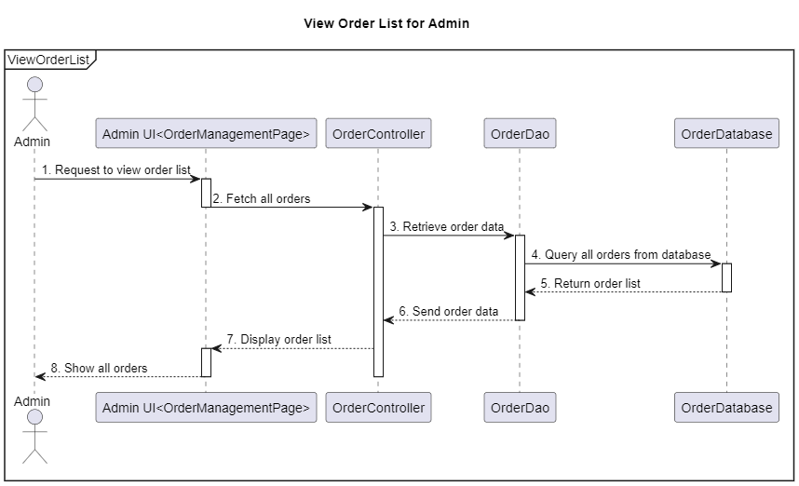
Update Order
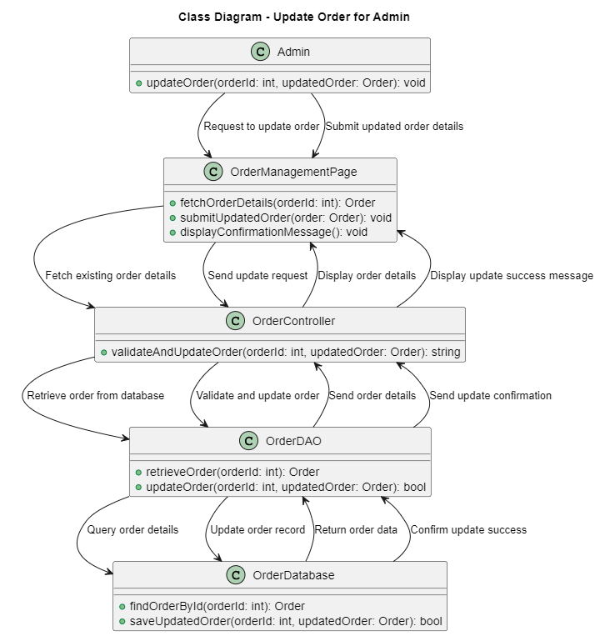
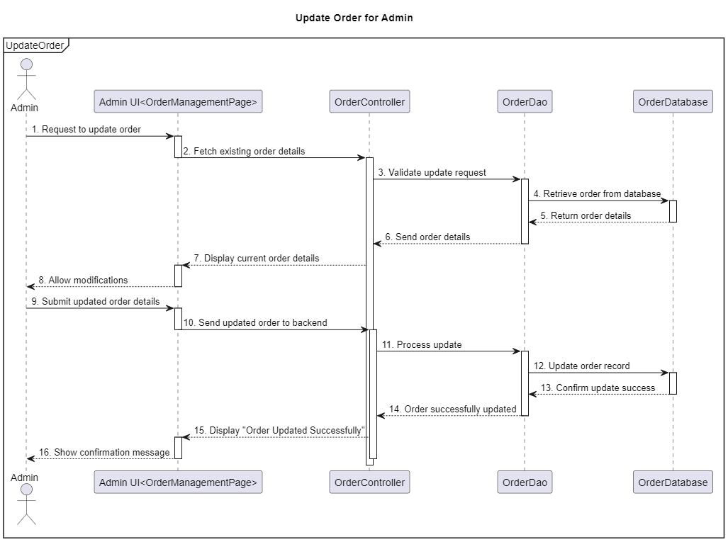
Delete Order
